Coleslaw Salad

ingredients: 1 half cabbage

1 carrot

1 onion

65 gram sugar

½ ts. salt

½ ts. pepper

½ cup milk

125gram mayonnaise

½ cup buttermilk

4 ts. white wine vinegar

6 ts. lemon juice

2 ts. paprika

2 ts. mustard

Cut the cabbage, the carrot and the onion in small strips (= Julienne).

Now you mix the vegetables in a big bowl.

After that you put the other ingredient into another bowl and mix it too.

You put the dressing over the mix of the vegetables.

Let the mixture pass for eight to ten hours.

Before you serve it, stir it a little bit.

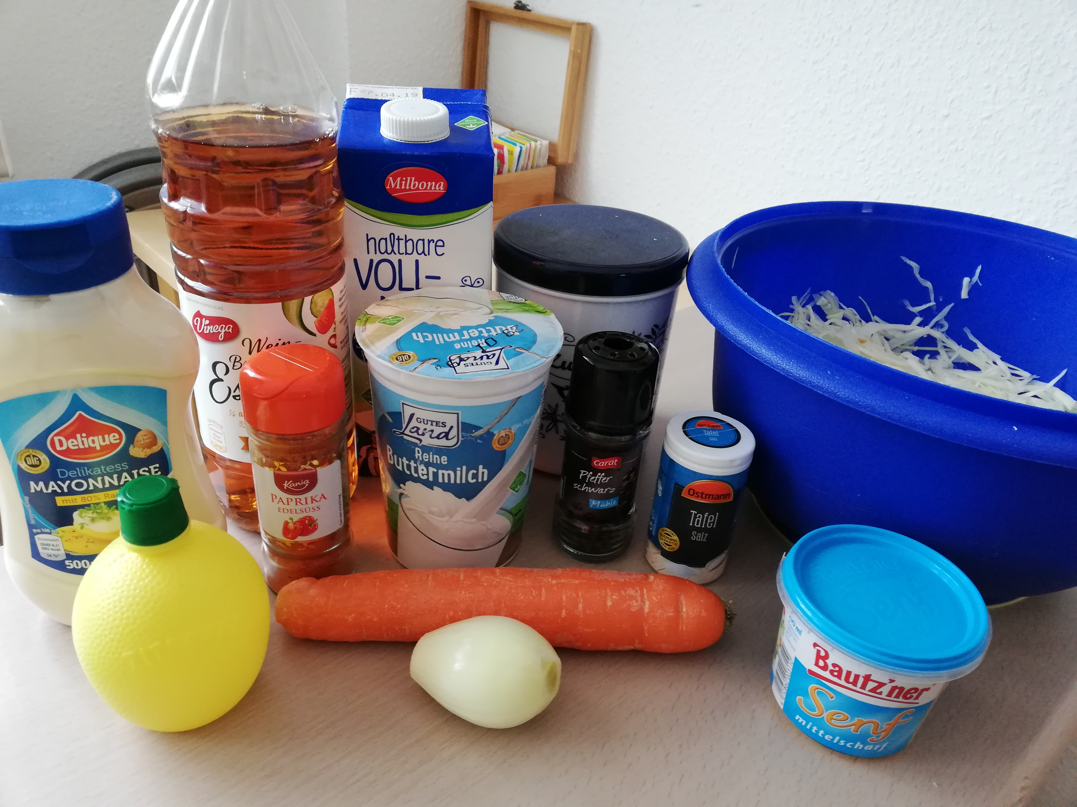

Enjoy your salad!

